In order page:

1. Show all function bars on the top of the page: etc. ship, invoice, CSL.
2. Show order# and company name on the top of left side corner. See example:

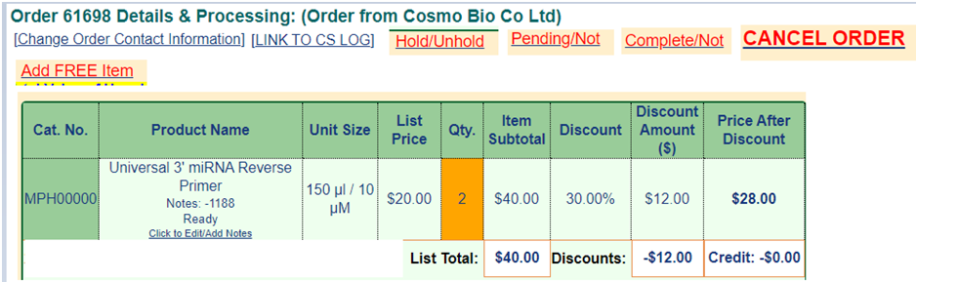

1. If customer placed an order when inventory has enough stock, it will show Green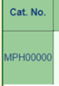. Otherwise shows red.

* For example, the product has enough inventory when order# 001 placed, so it shown green. But after order#002 placed, the inventory became negative (-1), so the product in order#002 shown red. But at this moment, the product in order#001 is still showing green, because it was in stock when order placed.

1. Add CSL link function bar on the top of the page as well. (so don’t have to go so many extra steps to search)

* So in CSL page, shows the CLS#, ORDER#, CAT#, QTY, Description, Group, EST.Comp.Date, last common, current employee, ship date, and complete (show YES OR NO) and edit.
* Able to edit notes in “common”, so we can add notes and special request, before save the notes in “common” able to select the name who have changed or added notes.
* In “edit”, able to switch current employee to other.
* When name switch to “Ryan-Complete”, it will becomes green, (if the order is not under Ryan-Complete , then always show red) and automatically send product ready email to [order@abmgood.com](mailto:order@abmgood.com) .

1. Make a place able to add and edit notes for the order.

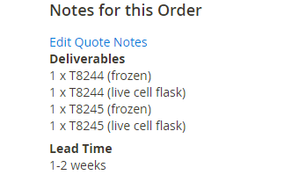

1. Put customer or distributor notes and information to the bottom of the order page.
2. Packing list

* Able to select any ship date for packing list (example: pop up a small calendar to choose the date, similar as old website)
* 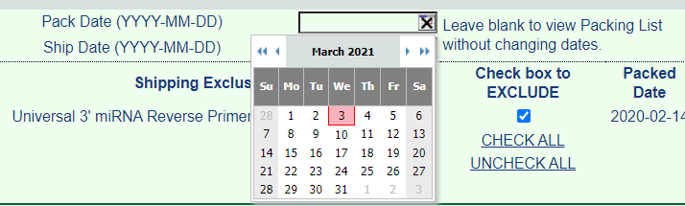
* Able to select which products are shipping today, example:
* 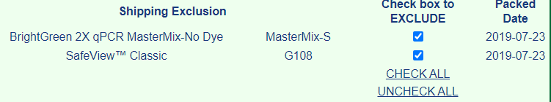
* And then press , to generate a packing list
* Show “bill to” on left side, “ship to” on right side (basically keep same as before.)
* Show important notes under the product chart. (etc. Deliverables, shipping company)
* Show “package verified by: “under the notes section.
* If virus, cells, chemicals, antibodies, and Growthfactors, link datasheets website page with Cat# or □, so when you press the cat# or □ on the packing list , it will pop up a new window shows datasheet and can be print out directly. (similar with old website)
* See example below:

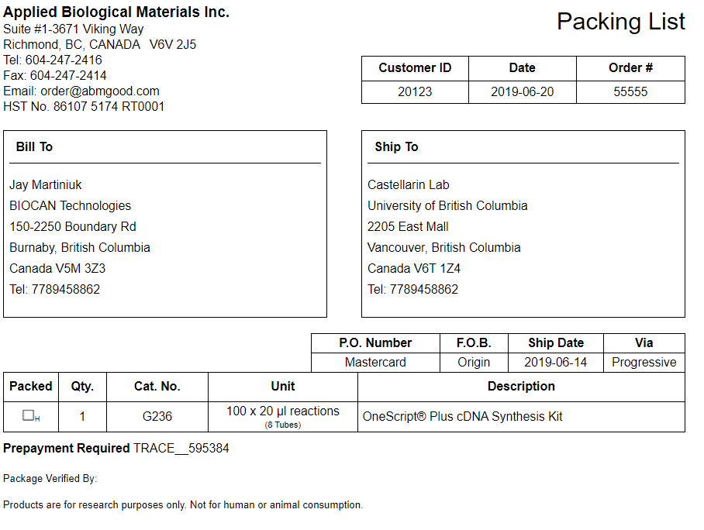

6. For order contact information, cannot be saved if missing any information. (etc. TAX ID)

7. Can edit or add special note for each product they ordered:

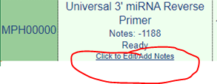

8. In the order page, make a place can add tracking number and carrier:

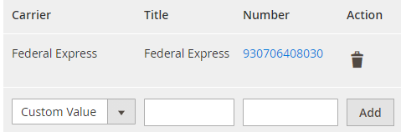

9. After press complete the order, the product will be disappeared in “Hold” 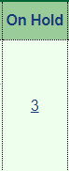 (I will explain “Hold” in inventory section.

Inventory

When you enter the cat# to search for inventory able to show:

1. Cat#

2. The number of instcok

3. Product name

4. Unit size

5. Price

6. Supplier

7. Location

(all above information can be changed in “Edit”)

8. On Hold (If this function can be shown on the same page, **(Prefer this, easy to use and shows all information in one page)**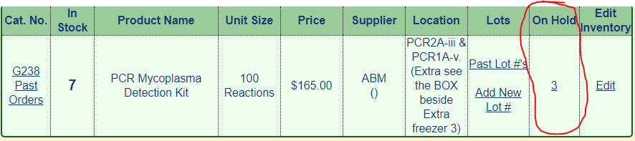

or you can also create a separate page like Magento “Product ship check” to show which product ordered by which order#.

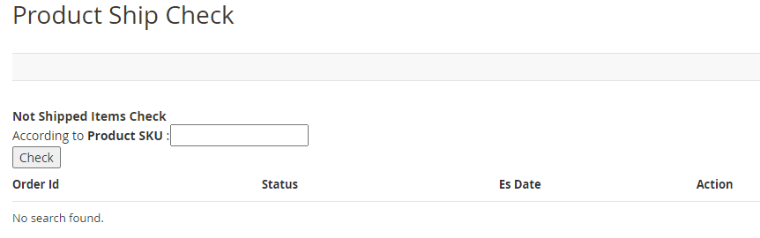

* After complete the order, the order number will be removed from “on hold”

1. It will show all components if the product contains more than one component:

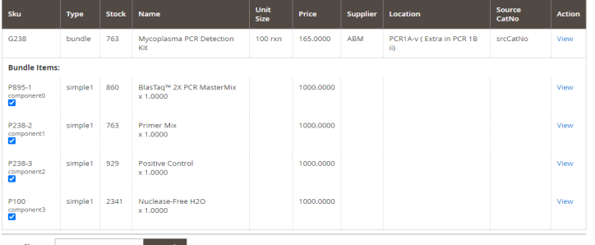

2. Able to edit the detail in this page when you select “view” in each component.

3. In each component shows number of vials in this kit:

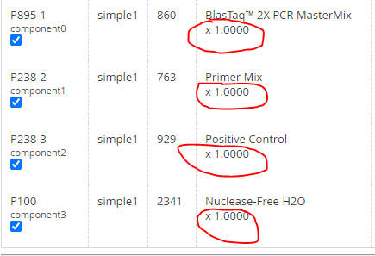

4. Show “Cat. No.'s That Include It” in “On hold when you search component 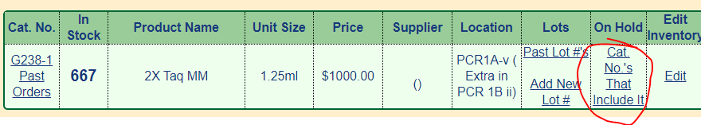

Select “Cat. No.'s That Include It” to check the kit cat#

